Reporting No:1 Week No:1 From :06/05/2024 To :11/05/2024 College ID: 22AIML012

Project Title: student collage recommendation system

**WEEKLY REPORT**

**Work done in last week ( Attach supporting Documents):**

1. Write a program for student detail.

2. use pickle for combine deta set.

3. find resources or available data from Kaggle.

4. find a e commerce old purchess data

**Reason for incomplete work:**

1. still study machine learning algorithams

**Plans for next week:**

1. learn tfidvectorizer algoritham.
2. learn random forest classifier.

**References:**

1. neso acedmy(youtube)

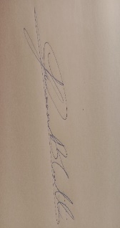

**Signature of External Guide Signature of Internal Guide**

Student Id: 22AIML012

Student Name: Yash Gajera